CASE STUDY REPORT

Data Analytics with Power BI

Government Arts College (Autonomous)-Coimbatore

**NM ID : bru001221bit226**

**NAME :** **KAMESH G**

**TRAINER NAME : R. UMAMAGESHWARI**

**MASTER TRAINER : R. UMAMAGESHWARI**

**“Analysis of Crypto Currency**

**Growth in last 5 years”**

**ABSTRACT**

Cryptocurrency represents a decentralized digital currency paradigm, revolutionizing traditional finance with its cryptographic foundations and peer-to-peer transaction mechanisms. Built upon blockchain technology, cryptocurrencies offer transparency, immutability, and security, enabling users to conduct trust less transactions without intermediaries. However, challenges persist, particularly in security and scalability. Security vulnerabilities, including hacking and fraudulent activities, undermine user trust, while scalability issues hinder transaction throughput and usability. Addressing these challenges requires innovative solutions, such as enhanced cryptographic protocols, refined consensus mechanisms, and novel scalability solutions like sharding and layer-2 protocols. Overcoming these hurdles promises to propel cryptocurrencies into mainstream adoption, fostering financial inclusion, and reshaping global economies



**INDEX**

|  |  |  |
| --- | --- | --- |
| **S. No.** | **Table of Contents** | **Page No.** |
| 1. | Chapter 1: Introduction | 1 |
| 2. | Chapter 2: Tools and Software Used | 4 |
| 3. | Chapter 3: Data Collection | 5 |
| 4. | Chapter 4: Project Architecture | 6 |
| 5. | Chapter 5: Modeling and Result | 8 |
| 6. | Conclusion | 10 |
| 7. | Future Scope | 11 |

**CHAPTER 1**

**INTRODUCTION**

**Problem Statement**

Cryptocurrencies, heralded for their decentralized nature and transparency, face critical challenges in security and scalability. Despite cryptographic protocols, the ecosystem grapples with ongoing threats like hacking and phishing, compounded by the anonymity of transactions, posing risks of fraud and financial losses. Moreover, vulnerabilities in smart contracts and blockchain protocols exacerbate these security concerns, fostering distrust among users. Concurrently, scalability issues loom large as transaction volumes surge, leading to network congestion and sluggish processing times. Bitcoin and Ethereum, in particular, struggle to handle the burgeoning demands efficiently, resulting in high fees and transaction delays that deter widespread adoption. Addressing these hurdles demands innovative solutions, encompassing robust cryptographic mechanisms, refined consensus algorithms, and optimized blockchain protocols. Exploring emerging technologies such as sharding and layer-2 solutions offers promise in alleviating scalability constraints, enhancing transaction throughput, and bolstering the usability of cryptocurrencies across various applications. By surmounting these challenges, the cryptocurrency ecosystem can fortify its resilience, cultivate user trust, and accelerate its integration into mainstream finance and commerce, ultimately realizing its transformative potential.

From this analysis we seek to answer the key questions such as:

1. **What is the total market capitalization and total trading volume of all cryptocurrencies over the provided dates?**
2. **How have the high, low, open, and close prices of each cryptocurrency fluctuated over time?**
3. **What is the average high and average low price of each cryptocurrency over the provided dates?**
4. **How many times did the high and low prices of each cryptocurrency exceed certain thresholds during the provided dates?**

**Proposed Solution**

Our proposed cryptocurrency solution aims to prioritize decentralization, security, and scalability. Leveraging a hybrid consensus mechanism that combines elements of Proof of Work and Practical Byzantine Fault Tolerance (PBFT), our blockchain ensures both robust security and fast transaction processing. This approach mitigates the drawbacks of Pow 's energy consumption while maintaining a high level of decentralization. Additionally, our blockchain architecture implements sharding techniques to enhance scalability, allowing for parallel transaction processing across multiple shards without sacrificing security.

Token -wise, we design a deflationary model with a fixed supply of tokens, ensuring scarcity and value preservation. Transaction fees are dynamically adjusted to incentivize network participation while preventing spam and congestion. Smart contract support enables the creation of decentralized applications for various use cases, fostering innovation within our ecosystem. With a user-friendly wallet interface and compliance with regulatory standards, our cryptocurrency solution targets mainstream adoption while adhering to legal requirements. Continuous community engagement, regular updates, and rigorous security audits ensure the ongoing improvement and stability of our cryptocurrency ecosystem.

**Advantages**

* Cryptocurrency offers numerous advantages over traditional fiat currencies and payment systems. Firstly, decentralization eliminates the need for intermediaries like banks, reducing transaction costs and enabling peer-to-peer transactions without geographical limitations. This autonomy also enhances financial inclusion, allowing access to banking services for the unbanked and underbanked populations worldwide.
* Moreover, cryptocurrencies provide enhanced security through cryptographic techniques like blockchain technology, which ensures immutability and transparency of transactions. This reduces the risk of fraud, identity theft, and counterfeit currency. Additionally, the borderless nature of cryptocurrencies facilitates cross-border transactions, bypassing traditional banking delays and fees.
* Furthermore, the programmable nature of smart contracts enables automated and transparent execution of agreements, streamlining processes in various industries like supply chain management, finance, and real estate. Cryptocurrencies represent a disruptive force with the potential to revolutionize the global financial system by promoting financial freedom, security, and efficiency.

**Scope**

**Global Financial Inclusion:**

Cryptocurrency has the potential to vastly improve financial inclusion by providing banking services to the unbanked and underbanked populations worldwide. With access to digital wallets and internet connectivity, individuals in remote areas can participate in the global economy, send and receive payments, and access financial services without relying on traditional banking infrastructure.

**Disruption of Traditional Finance:**

Cryptocurrency poses a significant challenge to traditional financial institutions by offering decentralized alternatives to banking, lending, and remittance services. As adoption grows, cryptocurrencies could reshape the financial landscape, reducing reliance on intermediaries and introducing new models of value transfer, investment, and wealth management.

**Technological Innovation and Use Cases:**

The scope of cryptocurrency extends beyond financial transactions, with applications in various industries such as supply chain management, healthcare, and voting systems. Blockchain technology, the underlying innovation behind cryptocurrencies, enables secure and transparent record-keeping, opening up possibilities for efficiency gains, fraud prevention, and data integrity across multiple sectors. As the technology evolves, new use cases and innovations will continue to emerge, expanding the scope and impact of cryptocurrencies on society.

**CHAPTER 2**

**TOOLS AND SOFTWARE USED**

**Tools and Software used:**

**Tools:**

* **PowerBI:** The main tool for this project is PowerBI, which will be used to create interactive dashboards for data visualization.
* **Power Query**: This is a data connection technology that enables you to discover, connect, combine, and refine data across a wide variety of sources.

**Software Requirements:**

* **PowerBI Desktop:** This is a Windows application that you can use to create reports and publish them to PowerBI.
* **PowerBI Service:** This is an online SaaS (Software as a Service) service that you use to publish reports, create new dashboards, and share insights.
* **PowerBI Mobile:** This is a mobile application that you can use to access your reports and dashboards on the go.

**CHAPTER 3**

**DATA COLLECTION**

Designing a Data collection for analyzing cryptocurrency involves gathering relevant information from various sources.

**1. Define Objectives:** Clearly outline the objectives of the analysis. Are you looking to understand market trends, investor sentiment, or blockchain activity? Define the specific metrics and parameters you aim to analyze, such as price movements, trading volume, network activity, or sentiment analysis from social media.

**2. Identify Data Sources:** Determine the sources of data required for your analysis. These may include cryptocurrency exchanges, blockchain explorers, social media platforms, news websites, forums, and specialized data providers. Ensure that the data sources are reliable, up-to-date, and cover a wide range of cryptocurrencies if needed.

**3. Data Collection Methods**: Choose appropriate methods for collecting data from selected sources. This may involve using APIs provided by exchanges and blockchain explorers to retrieve real-time data on prices, trading volumes, transaction histories, and blockchain metrics. For sentiment analysis, utilize natural language processing (NLP) techniques to gather and analysis data from social media platforms, forums, and news articles.

**4. Data Storage and Management:** Establish a robust system for storing and managing the collected data. Depending on the volume and frequency of data updates, consider using databases such as SQL or NoSQL databases for efficient storage and retrieval. Implement data validation and quality checks to ensure the integrity and accuracy of the collected data.

**5. Data Processing and Analysis:** Develop algorithms and models for processing and collected data. This may involve data cleansing, normalization, and aggregation to derive meaningful insights. Apply statistical and machine learning techniques to identify patterns, correlations, and anomalies in the data.

**6. Visualization and Reporting:** Create visualizations and reports to communicate the findings of the analysis effectively. Use charts, graphs, and dashboards to present key metrics and trends in an intuitive manner. Provide insights and recommendations based on the analysis to support decision- making processes.

**7. Iterative Improvement:** Continuously evaluate and refine the data collection process based on feedback and evolving requirements. Stay updated with new data sources, technologies, and analytical techniques to enhance the accuracy and relevance of the analysis over time.

**CHAPTER 4**

**PROJECT ARCHITECTURE**

Designing a project architecture for collecting and analyzing various crypto currency data involves several components and considerations. Here’s a high-level architecture for the Cryptocurrency Analysis project:

1. **Data Collection Layer:**

**Cryptocurrency Exchanges APIs:** Utilize APIs from major cryptocurrency exchanges to fetch real-time data on prices, trading volumes, and order book data.

1. **Data Processing Layer:**

**ETL Process**: Perform Extract, Transform, Load (ETL) operations to clean, transform, and aggregate raw data collected from various sources.

1. **Analysis and Modelling Layer:**

**Statistical Analysis:** Conduct statistical analysis to identify trends, correlations, and anomalies in the cryptocurrency market data.

1. **Risk Management and Compliance Layer:**

**Risk Assessment**: Assess risks associated with cryptocurrency investments including volatility, liquidity, regulatory risks, and security vulnerabilities.

1. **Integration and Deployment Layer:**

**Integration with Power BI**: Integrate the analysis platform with PowerBI for data visualization, dashboarding, and reporting purposes.

1. Security and Scalability Layer:

* **Data Security:** Implement robust security measures to protect sensitive cryptocurrency data from unauthorized access and cyber threats.
* **Scalability**: Design the architecture to scale efficiently to accommodate growing data volumes and user demands.

It’s also important to ensure that all tools and services comply with

relevant data privacy and security regulations

**CHAPTER 5**

**MODELING AND RESULT**

**Data Set:**

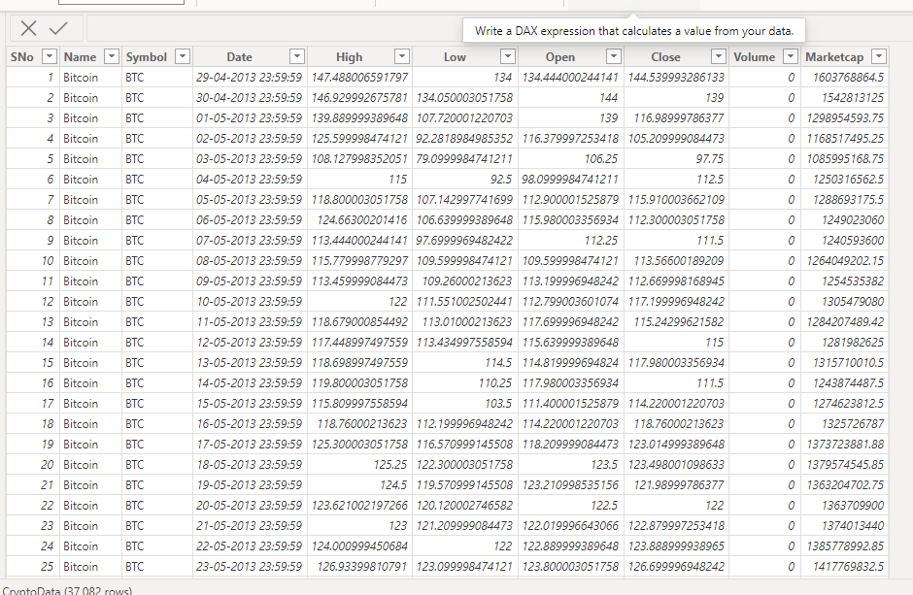

**Dashboard:**

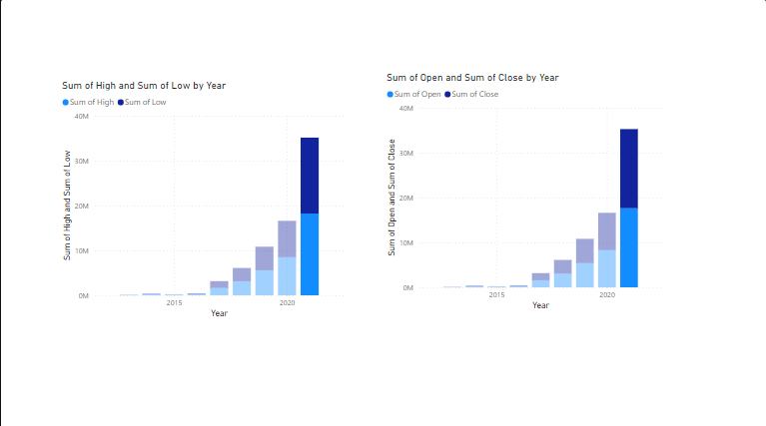

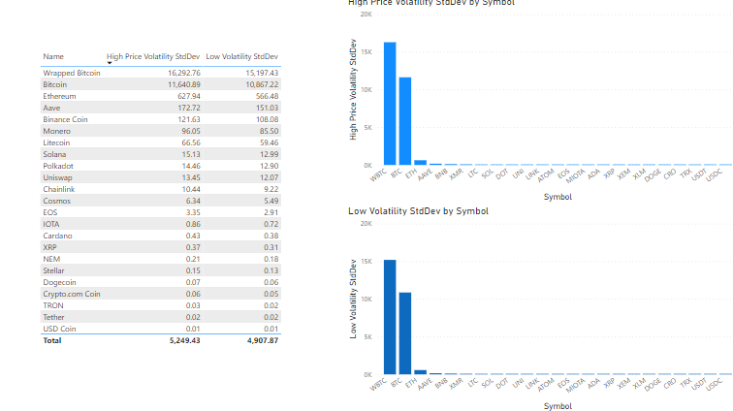

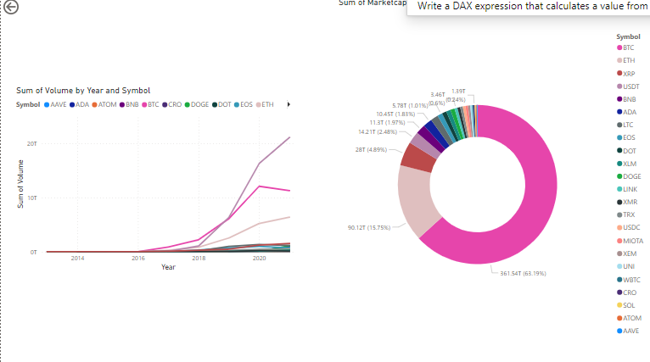

**CONCLUSION**

**In conclusion, designing a data collection process for analysing cryptocurrency is crucial for gaining insights into market dynamics, investor and blockchain activity. By defining clear objectives and identifying relevant data sources, one can gather comprehensive information on price movements, trading volumes, sentiment analysis, and blockchain metrics. Utilizing a combination of APIs, natural language processing techniques, and data validation processes ensures the reliability and accuracy of the collected data.**

**Moreover, implementing robust data storage, processing, and analysis methods enables the derivation of meaningful insights and actionable recommendations. Through visualization and reporting, stakeholders can gain a deeper understanding of market trends, identify opportunities, and mitigate risks effectively. Continuous iteration and improvement of the data collection process ensure its relevance and efficacy in the dynamic cryptocurrency landscape, allowing for informed decision-making and strategic planning.**

**Overall, a well-designed data collection process serves as a cornerstone for analysing cryptocurrency, enabling individuals, businesses, and researchers to navigate the complexities of the crypto market and capitalize on emerging opportunities in this rapidly evolving ecosystem. As the adoption of cryptocurrencies continues to grow, the importance of reliable and comprehensive data collection for analysis becomes increasingly paramount in driving informed decision-making and shaping the future of finance.**

**FUTURE SCOPE**

**The future scope of cryptocurrency analysis is vast and dynamic, poised for growth and innovation across multiple fronts. Advanced analytics techniques such as machine learning and big data analytics will be increasingly employed to uncover hidden patterns, predict market trends, and identify trading opportunities with greater precision. Moreover, the integration of cryptocurrency markets with traditional finance will lead to greater interoperability, facilitating cross-market analysis, portfolio diversification, and risk management strategies spanning both crypto and traditional asset classes. As regulatory frameworks evolve, there will be a rising demand for compliance solutions to ensure adherence to anti-money laundering (AML) and know your customer (KYC) regulations, as well as tax reporting requirements. Additionally, emerging use cases like decentralized finance (DeFi) and non-fungible tokens (NFTs) will drive the development of specialized analysis tools tailored to these applications. With institutional participation on the rise, institutions will require sophisticated risk management solutions, portfolio optimization tools, and performance analytics to navigate the crypto markets effectively while meeting regulatory standards. Overall, the future of cryptocurrency analysis holds immense potential for innovation and value creation, driven by advancements in technology, regulatory developments, and evolving market dynamics.**